Examination
Semester 1, 2017

Question/Answer booklet

HUMAN
BIOLOGY

Unit 1

Student number: In figures

In words ______________________________

______________________________

Time allowed for this paper
Reading time before commencing work: ten minutes
Working time: three hours

Materials required/recommended for this paper
To be provided by the supervisor
This Question/Answer booklet
Multiple-choice answer sheet

To be provided by the candidate
Standard items: pens (blue/black preferred), pencils (including coloured), sharpener, eraser, correction fluid/tape, ruler, highlighters

Special items: non-programmable calculators approved for the use in this examination

Important note to candidates
No other items may be taken into the examination room. It is your responsibility
to ensure that you do not have any unauthorised notes or other items of a non-
personal nature in the examination room. If you have any unauthorised material with
you, hand it to the supervisor before reading any further.

Structure of this paper

Section | Number of questions available | Number of questions to be answered | Suggested working time  (minutes) | Marks available | Percentage of exam
Section One:  Multiple-choice | 30 | 30 | 40 | 30 | 30
Section Two:  Short answer | 9 | 9 | 90 | 105 | 50
Section Three:  Extended answer | 3 | 2 | 50 | 40 | 20
 |  |  |  |  | 100

Instructions to candidates

- The rules for the conduct of the Western Australian Certificate of Education ATAR course examinations are detailed in the Year 11 Information Handbook 2017. Sitting this examination implies that you agree to abide by these rules.

- Answer the questions according to the following instructions.

Section One: Answer all questions on the separate Multiple-choice answer sheet provided. For each question, shade the box to indicate your answer. Use only a blue or black pen to shade the boxes. If you make a mistake, place a cross through that square then shade your new answer. Do no erase or use correction fluid/tape. Marks will not be deducted for incorrect answers. No marks will be given if more than one answer is completed for any question.

Section Two: Write your answers in this Question/Answer booklet. Whenever possible, confine your answers to the line spaces provided.

Section Three: Consists of three questions. You must answer two questions.
Tick the box next to the question you are answering.

- You must be careful to confine your answers to the specific questions asked and to follow any instructions that are specific to a particular question.

- Additional working space pages at the end of this Question/Answer booklet are for planning or continuing an answer. If you use these pages, indicate at the original answer, the page number it is planned/continued on and write the question number being planned/continued on the additional working space page.

Section One: Multiple- choice 30% (30 Marks)

This section has 30 questions. Answer all questions on the separate Multiple-choice answer sheet provided. For each question, shade the box to indicate your answer. Use only a blue or black pen to shade the boxes. If you make a mistake, place a box through that square then shade your new answer. Do not erase or use correction fluid/tape. No marks will be given if more than one answer is completed for any question.

Suggested working time: 40 minutes.
___________________________________________________________________

1. Which of the following substances can pass directly across the phospholipid bilayer of the plasma membrane without the assistance of a membrane protein?

(a) water
(b) glucose
(c) fatty acids
(d) amino acids

2. Phospholipids are comprised of

(a) hydrophobic heads and hydrophilic tails.
(b) fatty acids and glycerol.
(c) hydrophilic heads and hydrophobic tails.
(d) phosphate tails and lipid heads.

3. Active transport is best described as

(a) the movement of molecules from an area of high concentration to an area of low concentration.
(b) the movement of large molecules enclosed in a vesicle across a selectively permeable membrane.
(c) the movement of molecules across a selectively permeable membrane through a channel protein.
(d) the movement of molecules from an area of low concentration to an area of high concentration.

4. Emphysema is best described as

(a) a bacterial infection that affects the lungs.
(b) narrowing of the air passages in the lungs.
(c) uncontrolled cell division in the lungs.
(d) loss of elasticity of the air sacs in the lungs.

Questions 5 & 6 refer to the word equation below, which represents a catabolic enzyme (catalase) controlled reaction.

hydrogen peroxide water + oxygen

5. The substrate in the above reaction is

(a) water.
(b) oxygen.
(c) catalase.
(d) hydrogen peroxide.

6. The products of the above reaction are

(a) hydrogen peroxide and catalase.
(b) water and oxygen.
(c) catalase, water and oxygen.
(d) none of the above.

7. The diagram below represents an enzyme.

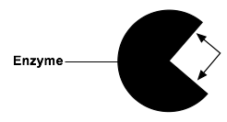
The arrows are pointing at the

(a) substrate site.
(b) catalyst site.
(c) active site.
(d) absolute site.

8. Proteins are comprised of which of the following elements?

(a) carbon, nitrogen, hydrogen and oxygen
(b) carbon, hydrogen, sulfur and oxygen
(c) nitrogen, carbon, phosphate and oxygen
(d) nitrogen, hydrogen, sodium and oxygen

9. Which of the following correctly identifies the part of the digestive system where fat is broken down into fatty acids and glycerol?

(a) small intestine
(b) stomach
(c) large intestine
(d) oesophagus

10. Lysosomes are organelles found in eukaryotic cells which

(a) are involved in the processing and packaging of proteins.
(b) are essential in the production of energy.
(c) provide a platform for the production of proteins.
(d) contain digestive enzymes for degradation of cellular material.

11. The diagram below represents one of the joint of the human skeleton.

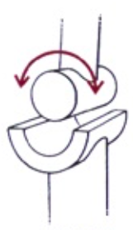

This joint is referred to as a

(a) hinge joint.
(b) ball and socket joint.
(c) pivot joint.
(d) saddle joint.

12. Cellular respiration can be described as

(a) a synthesis reaction.
(b) a catabolic reaction.
(c) an anabolic reaction.
(d) a reinforcing reaction.

13. ATP is a product of cellular respiration. ATP is formed when

(a) ATP is joined to an inorganic phosphate.
(b) ATP loses an inorganic phosphate.
(c) ADP is joined to an inorganic phosphate.
(d) ADP loses an inorganic phosphate.

14. The gall bladder is an organ associated with digestion. The substance stored in the gall bladder

(a) synthesises fat.
(b) emulsifies fat.
(c) solidifies fat.
(d) removes fat.

15. As part of an experiment into the effect of different solutions on fresh muscle tissue, 12 drops of ATP were added to a strand of fresh muscle of initial length 50mm. After a few minutes, it’s length was measured and found to be 42mm.
Which of the following lines correctly identifies the results of this experiment?

 | % difference in length of muscle strand | Reason for change
(a) | 8 | Contraction of muscle fibres
(b) | 8 | Relaxation of muscle fibres
(c) | 16 | Contraction of muscle fibres
(d) | 16 | Relaxation of muscle fibres

16. Which type of cell would possess the largest number of mitochondria?

(a) cartilage cell
(b) red blood cell
(c) cheek call
(d) muscle cell

17. Which of the following veins contains oxygenated blood?

(a) hepatic
(b) coronary
(c) pulmonary
(d) hepatic portal
18. Which of the following lines in the table below correctly identifies features of veins and arteries?

 | Feature | Artery | Vein
(a) | State of muscular wall | Thin | Thick
(b) | Diameter of lumen | Narrow | Wide
(c) | Valves | Present | Absent
(d) | Pressure of blood vessel | Low | High

19. The flow of lymph in lymphatic vessels is brought about mainly by

(a) pumping action of lymph nodes in the neck and groin.
(b) osmotic pressure of fluid absorbed by body tissues.
(c) pressure exerted by surrounding muscles on contraction.
(d) two lymphatic ducts opening into veins from arms.

20. Which of the following helps maintain high blood pressure in the glomerulus?

(a) The vessel entering the glomerulus is narrower than the one leaving it
(b) Plasma proteins in the bloodstream tend to force small molecules out of the blood
(c) Filtrate present in the capsule tends to draw further filtrate from the bloodstream by osmosis
(d) The blood vessel supplying the glomerulus contains blood arriving from the renal artery

21. The tissue type responsible for sending messages around the body is referred to as

(a) connective tissue.
(b) epithelial tissue.
(c) muscle tissue.
(d) nervous tissue.

22. Skeletal muscle is attached to bone by

(a) tendons.
(b) ligaments.
(c) joints.
(d) cartilage.

23. What type of movement is pictured in the diagram below?

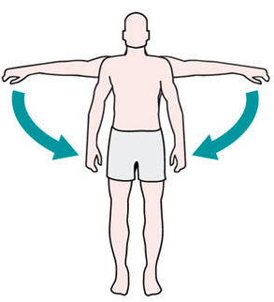
(a) flexion
(b) extension
(c) abduction
(d) adduction

Questions 24 and 25 refer to the diagram below.

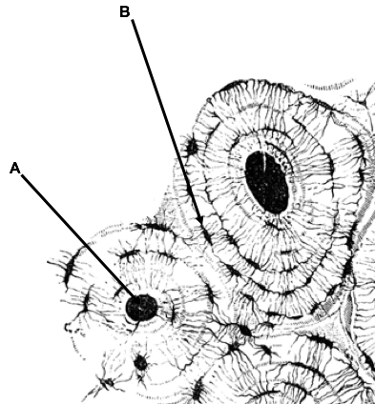

24. The structure labelled A is the

(a) central canal.
(b) lamellae.
(c) canaliculi.
(d) trabeculae.

25. Structure B is a lacuna. Each lacuna contains

(a) a leucocyte.
(b) an erythrocyte.
(c) an osteocyte.
(d) a chondrocyte.

26. During muscle contraction, the z lines

(a) move closer together.
(b) move further apart.
(c) become thicker.
(d) become thinner.

27. Contraction of the diaphragm causes

(a) an increase in volume of the lungs due to inhalation.
(b) a decrease in volume of the lungs due to inhalation.
(c) an increase in volume of the lungs due to exhalation.
(d) a decrease in volume of the lungs due to exhalation.

28. The trachea remains open despite the position of the neck. This is due to the presence of

(a) cartilage.
(b) bone.
(c) tendons.
(d) ligaments.

29. Which of the following cells does not carry out the process of phagocytosis?

(a) lymphocyte
(b) macrophage
(c) erythrocyte
(d) neutrophil

30. An example of exocytosis is

(a) oxygen crossing the cell membrane.
(b) secretion of enzymes out of the cell.
(c) movement of water via osmosis.
(d) carbon dioxide removal from cell.

Section Two: Short answer 50% (105 marks)

This section has nine (9) questions. Answer all questions. Write your answers in the spaces provided.

Additional working space pages at the end of this Question/Answer booklet are for planning or continuing an answer. If you use these pages, indicate at the original answer, the page number it is planned/continued on and write the question number being planned/continued on the additional working space page.

Suggested working time: 90 minutes
___________________________________________________________________

Question 31 (10 marks)

A student set up an experiment using model cells to investigate osmosis. The diagrams below show the apparatus used in the experiment.

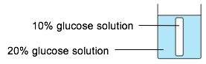
Cell A

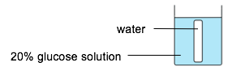
Cell B

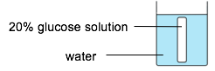
Cell C

The model cells were weighed before being placed in the beakers. After 2 hours the model cells were removed from the beakers and reweighed.

(a) Which of the model cells would have the greatest increase in mass after two hours? Give a reason for your choice. (3 marks)

__________________________________________________________________________________________________________________________________________________________________________________________
(b) Explain why dialysis tubing can be used to represent the cell membrane for this experiment. (2 marks)

____________________________________________________________________________________________________________________________

(c) Explain why it is important for the student to dry the model cells before each weighing. (2 mark)

______________________________________________________________

______________________________________________________________

(d) Diffusion and osmosis are two terms used to describe the movement of substances across the cell membrane. State one difference and two similarities between diffusion and osmosis. (3 marks)

__________________________________________________________________________________________________________________________________________________________________________________________

Question 32 (12 marks)

The diagram below represents the human digestive system.

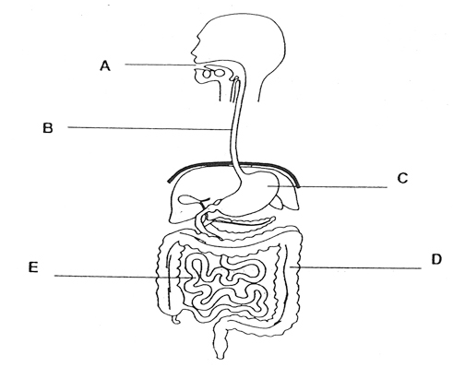
As food passes through the alimentary canal it is broken down both mechanically and chemically.

(a) Explain how structure A both mechanically and chemically breaks down food.
(4 marks)

________________________________________________________________________________________________________________________________________________________________________________________________________________________________________________________

(b) Name and describe the process by which food passes down structure B into the stomach. (3 marks)

__________________________________________________________________________________________________________________________________________________________________________________________
______________________________________________________________
______________________________________________________________

(c) Structure C is the stomach. The stomach contains gastric juices which aid in the process of digestion.
Complete the table below by outlining the function of the named gastric juices.
(2 marks)

Function
Hydrochloric acid

Digestive enzymes

(d) Contrast the structure and function of E and D. (3 marks)

__________________________________________________________________________________________________________________________________________________________________________________________
____________________________________________________________________________________________________________________________

Question 33 (13 marks)

Asthma is a common disease that affects the respiratory system.

It has long been known that asthma attacks can be triggered by exposure to irritating airborne particles such as mould spores, tobacco smoke and air pollution.

A study was carried out to show the effect of proximity to industrial plant exhaust fumes on people with asthma. A sample of the results gathered from this investigation is shown in the table below

Distance from industrial plant (km) | Reported cases of asthma
2 | 16
4 | 14
6 | 12
8 | 8
10 | 6

(a) Use the data in the table to draw a graph of the info in the table. (5 marks)

A spare grid is provided on page 35 of this Question/ Answer booklet. If you need to use it, cross out this attempt.

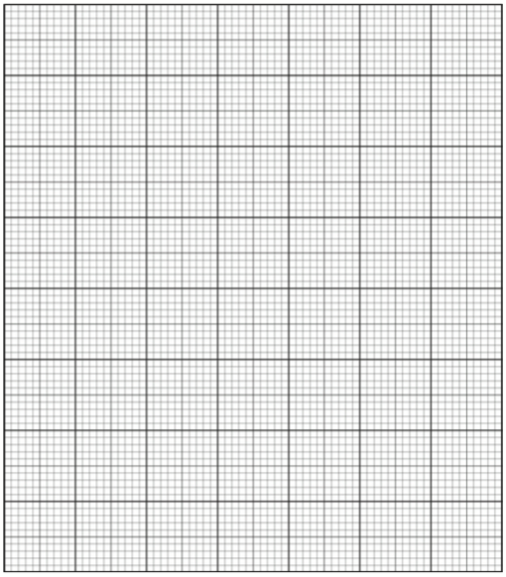

(b) Write a suitable hypothesis for this investigation. (2 marks)

____________________________________________________________________________________________________________________________

(c) Identify the dependent and independent variables in this investigation. (2 marks)

Dependent variable _____________________________________________

Independent variable ____________________________________________

(d) The investigation was repeated on several occasions. Each time it was repeated, the results were significantly different. One of the scientists involved in the investigation stated that the results were inaccurate.

Explain why the scientist could be correct in making this statement. (2 marks)

____________________________________________________________________________________________________________________________

(e) The scientists decided to trial a new asthma medication on the group. Half of the subjects were given the medication and the other half were given a placebo.
What is a placebo? (2 marks)

______________________________________________________________

______________________________________________________________

Question 34 (10 marks)

The process of aerobic respiration in a muscle cell is outlined below.

Glucose

Stage 1

Product Y

Stage 2

Carbon dioxide
+
water

(a) (i) Identify Stage 1 ________________________________ (1 mark)

(ii) Name product Y from stage 1 ______________________ (1 mark)

(iii) What other substance must be present in order for Stage 2 to occur? (1 mark)

_____________________________________________________

(iv) In which organelle does Stage 2 take place? (1 mark)

_____________________________________________________

(v) How many molecules of ATP are formed from each glucose molecule during both Stage 1 and Stage 2 combined? (1 mark)

_____________________________________________________

(b) Describe the process of anaerobic respiration. (4 marks)

______________________________________________________________ ______________________________________________________________ ______________________________________________________________
______________________________________________________________

(c) Give an example of a situation where anaerobic respiration would become very important. (1 mark)

______________________________________________________________

Question 35 (13 marks)

The statements in the table below describe the events during one cardiac cycle. The statements are not in the correct order.

A | Atria contract
B | Blood passes through the semi-lunar valves into the aorta and into the pulmonary artery
C | Blood passes through the atrioventricular valves into the ventricles
D | Ventricles relax
E | Ventricles contract

(a) Put one of the letters B to E into each box to show the events in the correct order. The first one has been done for you. (2 marks)

A

The diagram below represents the human heart and associated blood vessels.

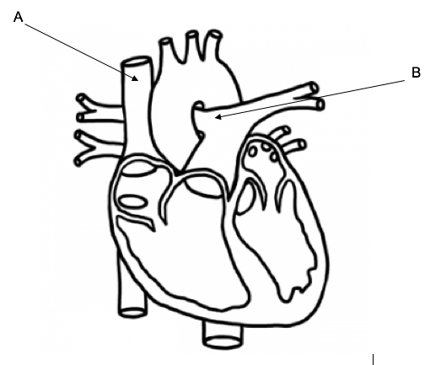

(b) (i) Identify blood vessels A and B. (2 marks)

A _______________________________________________________

B _______________________________________________________

(ii) Describe one (1) similarity and three (3) differences between blood vessels A and B. (4 marks)

______________________________________________________________ ______________________________________________________________ ______________________________________________________________
(c) Explain why the muscle on the left side of the heart thicker than the muscle on the right? (4 marks)

______________________________________________________________ ______________________________________________________________
______________________________________________________________ ______________________________________________________________

(d) Identify one (1) function of the valves in the heart. (1 mark)

______________________________________________________________ ______________________________________________________________

Question 36 (12 marks)

Lactose is a sugar found in milk which is broken down by the enzyme lactase. The word equation below outlines this chemical reaction.

Lactase
Lactose glucose + galactose

Figure 1 illustrates the rate at which lactose is broken down by lactase into glucose and galactose at different pH values.

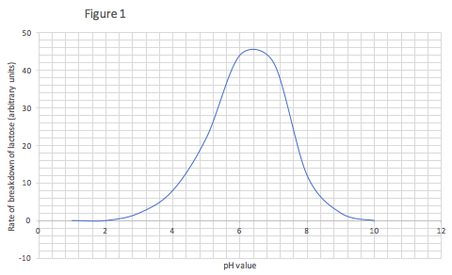

(a) Using the information from Figure 1 above, identify the optimum pH value for lactase. (1 mark)

______________________________________________________________

(b) Would it be possible for lipase to break down lactose? Explain your answer. (4 marks)

__________________________________________________________________________________________________________________________________________________________________________________________
____________________________________________________________________________________________________________________________

(c) The optimum temperature for enzymes in the human body is 37ºC. Explain what would happen to enzymes if a person’s body temperature increased to 45ºC. (3 marks)

____________________________________________________________________________________________________________________________

(d) Some enzymes require a cofactor in order to combine with their substrate. Briefly outline the role of a cofactor in the efficient functioning of an enzyme. (2 marks)

______________________________________________________________

______________________________________________________________

The graph below illustrates an increase in substrate concentration and its effect on the rate of an enzyme controlled reaction.

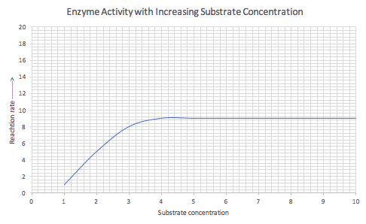
(e) Explain why the reaction rate does not continue to increase after the substrate concentration reaches 4 on the graph. (2 marks)

____________________________________________________________________________________________________________________________

Question 37 (14 marks)

Blood is a transport medium. It allows essential substances to be carried around the body and transports waste products to the organs of excretion.
Blood consists of a straw-coloured liquid named plasma and solid components referred to as formed elements.
These formed elements are commonly known as red blood cells, white blood cells and platelets.

(a) What role does each of the following formed elements play in the body?
(2 marks)

White blood cells _______________________________________________

Platelets ______________________________________________________

(b) The function of red blood cells is to transport oxygen around the body.

(i) Identify the substance that increases the oxygen carrying capacity of the red blood cell. (1 mark)

_______________________________________________________

(ii) Describe two (2) other features of red blood cells which increase their oxygen delivery capacity to cells. (2 marks)

________________________________________________________

________________________________________________________

(c) A second transport mechanism within the body is the lymphatic system. The lymphatic system is made up of lymphatic capillaries, lymph vessels and lymph nodes.

(i) What is the function of the lymphatic system? (3 marks)

________________________________________________________

________________________________________________________

________________________________________________________

(ii) Identify two (2) locations in the body where lymph nodes can be located. (2 marks)

________________________________________________________

________________________________________________________

(iii) Explain why lymph nodes can become larger when you have an infection. (2 marks)

________________________________________________________

________________________________________________________

(iv) What is the advantage of lymph passing through several lymph nodes before returning to the circulatory system? (2 marks)

________________________________________________________

________________________________________________________

Question 38 (10 marks)

Lining the wall of the small intestine are many tiny projections known as villi. Products of digestion are absorbed through the villi and used to fuel the body. A diagram of a villus is shown below.

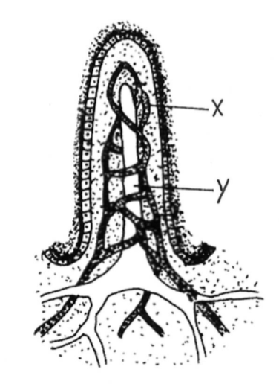

(a) (i) Identify structures X and Y in the diagram above. (2 marks)

X ____________________________________________________________

Y ____________________________________________________________

(ii) Which of the products of digestion are absorbed into the structures labelled X and Y in the above diagram? (2 marks)

X ____________________________________________________________

Y ____________________________________________________________

(b) Describe two (2) features of the villi which makes them an efficient surface for nutrient absorption. (4 marks)

______________________________________________________________ ______________________________________________________________ ______________________________________________________________ ______________________________________________________________

(c) Coeliac disease is caused by an allergy to gluten. The disease causes the villi to be destroyed.
Explain why a person suffering from coeliac might struggle to gain weight. (2 marks)

______________________________________________________________

______________________________________________________________

Question 39 (11 marks)

The diagram below illustrates a contracted bicep muscle and a relaxed tricep muscle.
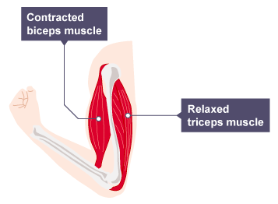
(a) The bicep and tricep are referred to as an antagonistic pair.

(i) Which muscle would be the agonist and which would be the antagonist.
(2 marks)

Agonist __________________________________________________

Antagonist _______________________________________________

(ii) Explain why having muscles arranged in antagonistic pairs is an advantage. (2 marks)

________________________________________________________

________________________________________________________

________________________________________________________

(b) Myofilaments are the basic unit of skeletal muscle which allow muscles to contract and relax.
The diagram below shows the myofilaments in a relaxed (A) and a contracted (B) state.

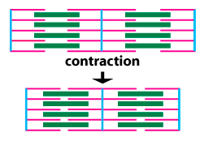

A

B

(i) Identify the two myofilaments labelled in the diagram. (2 marks)

A __________________________________

B __________________________________

(ii) The sliding filament theory has been proposed to explain muscular contraction. Briefly describe the sliding filament theory. (5 marks)

______________________________________________________________ ______________________________________________________________ ______________________________________________________________ ______________________________________________________________ ______________________________________________________________

Section Three: Extended answer 20% (40 Marks)

This section has three (3) questions. You must answer two (2) questions. Write your answers on the lined pages provided.

Additional working space pages at the end of this Question/Answer booklet are for planning or continuing an answer. If you use these pages, indicate at the original answer, the page number it is planned/continued on and write the question number being planned/continued on the additional working space page.

Responses could include clearly labelled diagrams with explanatory notes; lists of points with linking sentences; clearly labelled tables and graphs; and annotated flow diagrams with introductory notes.

Suggested working time: 50 minutes.
___________________________________________________________________

Answer any two (2) questions from Questions 40-42

Question 40 (20 marks)

As a result of the many metabolic processes taking place in the body, waste products can build up. These wastes must be removed from the body.
The organs of excretion help remove these waste products from the body so that they do not build up and become toxic.
The main organs of excretion are the lungs, sweat glands, liver and kidneys.

The liver carries out many roles. It receives blood from the digestive system and performs several detoxification functions.
One specific function of the liver is the removal of nitrogenous waste products. This process is referred to as ‘deamination’.

(a) Describe the process of deamination and explain its importance in the removal of waste. (6 marks)

(b) The kidney is the main organ of excretion. Each kidney contains approximately 1 million tiny structures called nephrons. Starting with the afferent arteriole, explain how glomerular filtrate becomes urine under the headings of filtration, reabsorption and secretion. (14 marks)

Question 41 (20 marks)

Two men are working on a job site and both have accidently cut themselves while carrying a sheet of metal

One of the men cleans his cut to prevent bacteria and other pathogens from entering the wound. After applying some pressure to the cut, he notices that the bleeding is slowing down and after a few more minutes, the bleeding stops.

(a) Explain the process of blood clotting that has just occurred. (8 marks)

The second man suffers from a condition called haemophilia. A person who suffers from haemophilia is missing a particular protein which allows the blood to clot.
This man’s blood does not clot and he is in danger of losing a large volume of blood. He is taken to the hospital and may have to have a blood transfusion.
He explains that he is blood type A.

(b) Why is it important for him to advise the hospital staff of his blood type before receiving a transfusion. (4 marks)

(c) Name and give a brief description four (4) types of blood transfusion that a person may have. (8 marks)

Question 42 (20 marks)

Bone and cartilage are two types of connective tissue.

(a) Describe the microscopic structure of bone. (8 marks)

(b) There are several different types of cartilage found in the body. Briefly discuss the main functions of cartilage and explain why cartilage may take longer to heal than bone. (4 marks)

(c) As we age, our bones can deteriorate. Name and describe two (2) conditions that affect our bones as we age.
Include in your answer the name of the condition, the cause, symptoms and an appropriate treatment for each. (8 marks)

______________________________________________________________________________________________________________________________________________________________________________________________________________________________________________________________________________________________________________________________________________________________________________________________________________________________________________________________________________________________________________________________________________________________________________________________________________________________________________________________________________________________________________________________________________________________________________________________________________________________________________________________________________________________________________________________________________________________________________________________________________________________________________________________________________________________________________________________________________________________________________________________________________________________________________________
______________________________________________________________________________________________________________________________________________________________________________________________________________________________________________________________________________________________________________________________________________________________________________________________________________________________________________________________________________________________________________________________________________________________________________________________________________________________________________________________________________________________________________________________________________________________________________________________________________________________________________________________________________________________________________________________________________________________________________________________________________________________________________________________________________________________________________________________________________________________________________________________________________________________________________________
______________________________________________________________________________________________________________________________________________________________________________________________________________________________________________________________________________________________________________________________________________________________________________________________________________________________________________________________________________________________________________________________________________________________________________________________________________________________________________________________________________________________________________________________________________________________________________________________________________________________________________________________________________________________________________________________________________________________________________________________________________________________________________________________________________________________________________________________________________________________________________________________________________________________________________________
___________________________________________________________________

______________________________________________________________________________________________________________________________________________________________________________________________________________________________________________________________________________________________________________________________________________________________________________________________________________________________________________________________________________________________________________________________________________________________________________________________________________________________________________________________________________________________________________________________________________________________________________________________________________________________________________________________________________________________________________________________________________________________________________________________________________________________________________________________________________________________________________________________________________________________________________________________________________________________________________________
______________________________________________________________________________________________________________________________________________________________________________________________________________________________________________________________________________________________________________________________________________________________________________________________________________________________________________________________________________________________________________________________________________________________________________________________________________________________________________________________________________________________________________________________________________________________________________________________________________________________________________________________________________________________________________________________________________________________________________________________________________________________________________________________________________________________________________________________________________________________________________________________________________________________________________________
______________________________________________________________________________________________________________________________________________________________________________________________________________________________________________________________________________________________________________________________________________________________________________________________________________________________________________________________________________________________________________________________________________________________________________________________________________________________________________________________________________________________________________________________________________________________________________________________________________________________________________________________________________________________________________________________________________________________________________________________________________________________________________________________________________________________________________________________________________________________________________________________________________________________________________________
__________________________________________________________________________________________________________________________________________________________________________________________________________________________________________________________________________________________________________________________________________________________________________________________________________________________________________________________________________________________________________________________________________________________________________________________________________________________________________________________________________________________________________________________________________________________________________________________________________________________________________________________________________________________________________________________________________________________________________


References

Question 11- Skeletal joints http://cheppila.com/wp-content/uploads/2014/07/Untitled-3.jpg Accessed 20th February 2017

Question 23 Movement http://machinedesign.com/medical/what-s-difference-between-abduction-and-adduction-biomechanics Accessed 12th February 2017

Question 24 & 25- Microscopic bone http://etc.usf.edu/clipart/50700/50764/50764_micro.htm Accessed 10th February 2017

Question 32- Digestive system http://anatomyofthefoot.com/unlabeled-diagram-of-the-digestive-system.html Accessed 8th February 2017

Question 35- Heart http://cliparts.co/clipart/152140 Accessed 24th February 2017

Question 38 Villi http://www.advance-africa.com/KCSE-Past-Papers-General-Science-2011.html Accessed 20th February 2017

Question 39- Bicep and tricep http://www.bbc.co.uk/education/guides/zpkq7ty/revision/3 Accessed 14th February 2017

Question 39-Muscle contraction https://courses.washington.edu/conj/bess/muscle/structurefunc2.html Accessed 12th February 2017

